LINKS UTEIS

<https://github.com/crankdaworld/OpenCV-Android-FaceDetect-GoodFeature/blob/master/OpenCV-Android-FaceDetect-GoodFeature/face-detection/src/org/opencv/samples/fd/WorkingHeadPose.java>

<https://github.com/Itseez/opencv/blob/master/samples/cpp/lkdemo.cpp>

<https://github.com/pupil-labs/pupil/blob/master/pupil_src/shared_modules/square_marker_detect.py>

<http://romanhosek.cz/android-eye-detection-and-tracking-with-opencv/>

<https://developer.android.com/guide/components/index.html>

Livro 1:

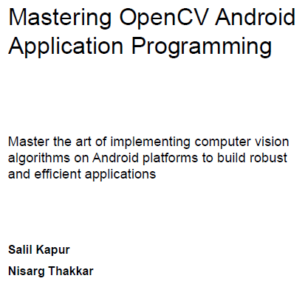



Livro 2:

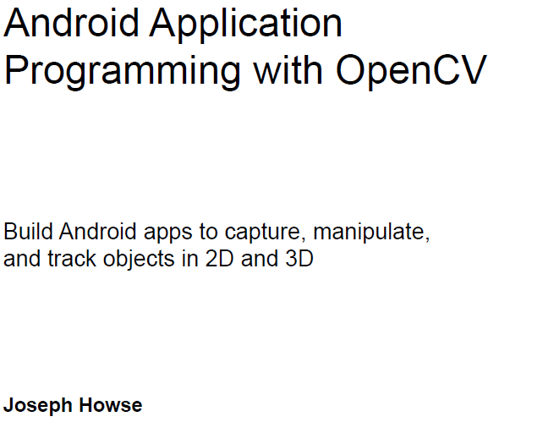



Referências (teoria)

<http://www.academia.edu/9158427/Detec%C3%A7%C3%A3o_de_faces_atrav%C3%A9s_do_algoritmo_de_Viola-Jones>

<http://www.bitabit.eng.br/2011/02/21/como-detectar-faces-em-videos/>

<https://en.wikipedia.org/wiki/Viola%E2%80%93Jones_object_detection_framework>

<http://mtc-m21b.sid.inpe.br/col/sid.inpe.br/mtc-m21b/2014/06.13.13.01/doc/publicacao.pdf>

<https://en.wikipedia.org/wiki/Lucas%E2%80%93Kanade_method>

<http://agostinhobritojr.github.io/cursos/pdi/fluxo.pdf>